Case Study Report



**Tech Saksham**

Data Analytics with Power BI

**“ANALYSIS OF COMMERCIAL ELECTRICITY CONSUMPTION IN INDIAN STATE ”**

**“St JOHN’S COLLEGE”**

|  |  |
| --- | --- |
| **NM ID** | **NAME** |
| 025A0D6FF70111791804130F85CC3549 | **GODSON RAJA J** |

|  |  |
| --- | --- |
|  |  |
|  | Trainer Name UMAMAHESHWARI R |
|  | Master TrainerUMAMAHESHWARI R |

**ABSTRACT**

Electricity consumption analysis is crucial for effective energy management and policy formulation, particularly in rapidly developing regions like Indian states. This study focuses on analyzing commercial electricity consumption patterns in a specific Indian state, leveraging data analytics techniques and the Power BI platform.

Data from diverse sources including governmental agencies, utility providers, and weather repositories were collected and integrated using Power BI's data preparation capabilities. The dataset underwent rigorous cleansing and preprocessing to ensure accuracy and consistency.

Through interactive visualizations and dashboards created in Power BI, comprehensive insights into commercial electricity consumption trends were obtained. Time-series analysis revealed seasonal variations and peak demand periods, while correlation analysis uncovered relationships between consumption patterns and economic indicators, as well as weather conditions.

**INDEX**

|  |  |  |
| --- | --- | --- |
| **Sr. No.** | **Table of Contents** | **Page No.** |
| 1 | Chapter 1: Introduction | 4 |
| 2 | Chapter 2: Services and Tools Required | 5 |
| 3 | Chapter 3: Project Architecture | 7 |
| 4 | Chapter 4: Modeling and Result | 9 |
| 5 | Conclusion | 14 |
| 6 | Future Scope | 15 |
| 7 | References | 16 |
| 8 | Links | 17 |

**CHAPTER 1**

**INTRODUCTION**

* 1. **Problem Statement**

The commercial sector accounts for a significant portion of electricity consumption in Indian states, and understanding its consumption patterns is essential for effective energy management and policy-making. However, the lack of comprehensive analysis and insights into commercial electricity consumption poses challenges for policymakers and energy managers.

* 1. **Proposed Solution**

To address the challenges outlined in the problem statement, we propose a comprehensive solution leveraging data analytics techniques and the Power BI platform..

* 1. **Feature**
* **Real-Time Analysis**: The dashboard will provide real-time analysis of electricity consumption.
* **Consumption Segmentation**: It will segment consumption based on various parameters like environment, income, employment, etc.
* **Trend Analysis**: The dashboard will identify and display trends in consumption behavior.
* **Predictive Analysis**: It will use historical data to predict future consumption behavior.

**1.4Advantages**

**User-Friendly Interface:** Power BI provides an intuitive interface that allows users to easily navigate through data and create interactive visualizations without extensive technical expertise.

**Integration with Multiple Data Sources:** Power BI seamlessly integrates with various data sources, including cloud-based repositories, databases, and spreadsheets.

**Interactive Visualizations:** Power BI offers a wide range of interactive visualization options, including charts, graphs, maps, and tables.

**1.5Scope**

**Data Collection:**

* Gathering data on commercial electricity consumption from relevant sources such as governmental agencies, utility providers, and open data repositories.

**Data Preparation and Integration:**

* Cleaning and preprocessing the collected data to handle missing values, outliers, and inconsistencies.

**Data Analysis and Visualization:**

* Utilizing Power BI's visualization capabilities to create interactive dashboards and reports.

**CHAPTER 2**

**SERVICES AND TOOLS REQUIRED**

Analyzing commercial electricity consumption in an Indian state using Power BI requires a combination of services and tools to effectively gather, process, analyze, and visualize data. Here's a list of the essential Power BI services and tools needed for this analysis:

1. **Power BI Desktop:**
   * Power BI Desktop is a free desktop application that allows users to connect to data, transform and model data, create interactive visualizations, and build reports and dashboards.
2. **Power BI Service:**
   * Power BI Service is a cloud-based platform that allows users to publish, share, and collaborate on Power BI reports and dashboards. It provides features for data governance, sharing, and collaboration.
3. **Data Sources:**
   * Access to relevant data sources containing information on commercial electricity consumption, economic indicators, demographics, and weather conditions. This may include databases, APIs, spreadsheets, or cloud-based data repositories.
4. **Data Connectivity:**
   * Power BI offers connectivity to a wide range of data sources, including SQL databases, Excel files, CSV files, web services, and cloud-based platforms like Azure Blob Storage and Amazon Redshift. Ensure compatibility with the data sources used for the analysis.
5. **Data Preparation Tools:**
   * Power BI Desktop includes Power Query, a data preparation tool that allows users to clean, transform, and manipulate data before analysis. Power Query simplifies tasks such as filtering, merging, and pivoting data to prepare it for analysis.
6. **Visualization Tools:**
   * Power BI provides a variety of visualization tools, including bar charts, line charts, pie charts, maps, and gauges, to create interactive and insightful visualizations of the data. Users can customize the appearance and formatting of visualizations to suit their needs.
7. **Advanced Analytics Features:**
   * Power BI offers advanced analytics features such as forecasting, clustering, and sentiment analysis. These features allow users to gain deeper insights into the data and identify patterns, trends, and anomalies.
8. **Time Series Forecasting:**
   * Power BI includes built-in time series forecasting capabilities that enable users to generate forecasts for future electricity consumption trends. Users can adjust forecasting parameters and evaluate forecast accuracy using performance metrics.
9. **Collaboration and Sharing:**
   * Power BI Service facilitates collaboration and sharing of reports and dashboards with stakeholders. Users can publish reports to the Power BI Service, share them with specific users or groups, and collaborate on shared datasets and reports.
10. **Security and Governance:**
    * Power BI offers features for data security and governance, including role-based access control, data encryption, and compliance with regulatory standards such as GDPR and HIPAA. Ensure that appropriate security measures are implemented to protect sensitive data.
11. **Training and Support:**
    * Access to training resources, documentation, and community forums to learn how to use Power BI effectively and troubleshoot any issues that may arise during the analysis process.

**CHAPTER 3**

**PROJECT ARCHITECTURE**

**3.1 Architecture**

Project architecture for analyzing commercial electricity consumption in an Indian state using Power BI involves designing a structured framework that outlines the flow of data and processes from data collection to insights generation. Here's a proposed project architecture:

1. **Data Collection:**
   * Gather data from various sources such as governmental agencies, utility providers, weather repositories, and economic databases. This data should include information on commercial electricity consumption, economic indicators, demographics, and weather conditions.
2. **Data Preparation:**
   * Cleanse and preprocess the collected data using Power BI Desktop's data preparation tools, such as Power Query. Address missing values, outliers, and inconsistencies, and transform the data into a suitable format for analysis.
3. **Data Modeling:**
   * Model the preprocessed data within Power BI Desktop to create a data model that reflects the relationships between different data entities. Define measures, calculated columns, and hierarchies to facilitate analysis and visualization.
4. **Data Visualization:**
   * Design interactive visualizations and dashboards using Power BI Desktop to analyze commercial electricity consumption patterns. Utilize various visualization tools such as charts, graphs, maps, and tables to visualize consumption trends, correlations, and anomalies.
5. **Time Series Forecasting:**
   * Implement time series forecasting models within Power BI Desktop to predict future electricity consumption trends. Choose appropriate forecasting algorithms and adjust parameters to optimize forecast accuracy.
6. **Insights Generation:**
   * Analyze the visualizations and forecasting results to derive actionable insights into commercial electricity consumption patterns. Identify trends, seasonality, peak demand periods, and factors influencing consumption.
7. **Report Publishing:**
   * Publish reports and dashboards to the Power BI Service to share insights with stakeholders. Utilize Power BI Service's collaboration features to share reports with specific users or groups and facilitate collaboration on shared datasets and reports.
8. **Monitoring and Maintenance:**
   * Monitor the performance and accuracy of the analysis over time and make adjustments as necessary. Continuously update data sources, refresh data, and refine analysis techniques to ensure relevance and accuracy.
9. **Security and Governance:**
   * Implement security and governance measures to protect sensitive data and ensure compliance with regulatory standards. Utilize Power BI Service's security features such as role-based access control and data encryption.
10. **Documentation and Training:**
    * Document the project architecture, data sources, processes, and analysis techniques for future reference. Provide training and support to users on how to access, analyze, and interpret the insights generated from the Power BI analysis.

By following this project architecture, analysts can effectively analyze commercial electricity consumption in an Indian state using Power BI, derive actionable insights, and drive informed decision-making to optimize energy management practices.

**CHAPTER 4**

**MODELING AND RESULT**

**Modelling for date and time for power consumption during periods**

Notice that the date and time are includedin the data. These can be formulated by removing time and inserting separate colums for year and month.



**Dashboard**

**BEFORE LOCKDOWN**

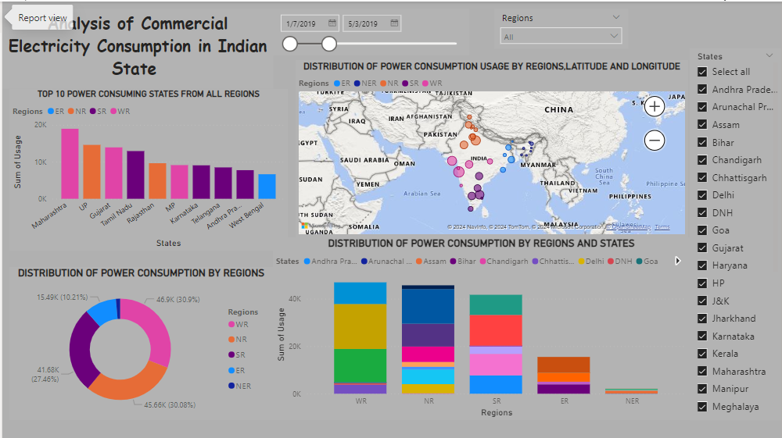

**AFTER LOCKDOWN**

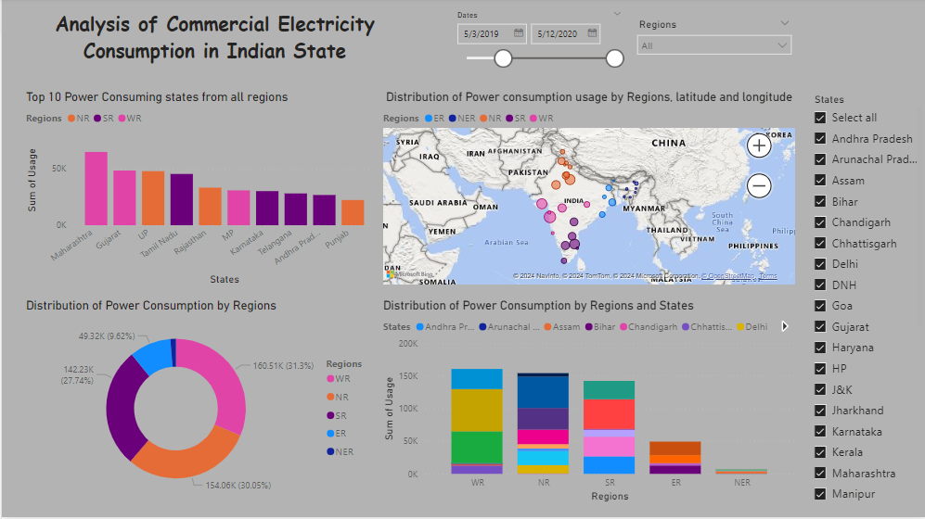

**CONCLUSION**

The analysis of commercial electricity consumption in [Indian State] using Power BI has provided valuable insights into the trends, patterns, and drivers of electricity usage in the commercial sector.The analysis underscores the importance of monitoring and analyzing commercial electricity consumption trends to support sustainable development, energy security, and economic growth in [Indian State]. By applying data analytics tools like Power BI, policymakers, utilities, and businesses can collaborate to optimize energy usage, mitigate environmental impacts, and ensure a reliable supply of electricity for future generations.

Top of Form

**FUTURE SCOPE**

The analysis of commercial electricity consumption in [Indian State] using Power BI has provided valuable insights into current consumption patterns and trends. However, there are several areas where future research and analysis can further enhance our understanding and support more effective decision-making. Here are some potential avenues for future exploration:

1. **Granular Analysis**:
   * Conduct a more granular analysis of commercial electricity consumption by industry sectors, geographic regions, or business sizes. This would provide deeper insights into specific consumption patterns and drivers within different segments of the commercial sector.
2. **Integration of External Data Sources**:
   * Incorporate external data sources such as weather data, economic indicators, population demographics, and business activity indices into the analysis. Integrating these factors can help identify correlations and causal relationships that influence commercial electricity consumption.

**REFERENCES**

https://github.com/godraja/Analysis-of-Commercial-Electricity-Consumption-in-Indian-State-.git